# **Name: Abdurrahman Qureshi**

# **Roll No: 210451**

Practical No: 7

**1) Write a Program to create an image**

**CODE:**

<?php  
$width = 500;  
$height = 500;  
$img = imagecreate($width, $height);  
header('Content-Type: image/jpeg');  
$bg_color = imagecolorallocate($img, 29, 29, 29);  
$txt_color = imagecolorallocate($img, 0, 0, 0);  
*//imagestring($img, 5, 5, 5, "qarq90", $txt_color);*imagejpeg($img);  
?>

**OUTPUT:**

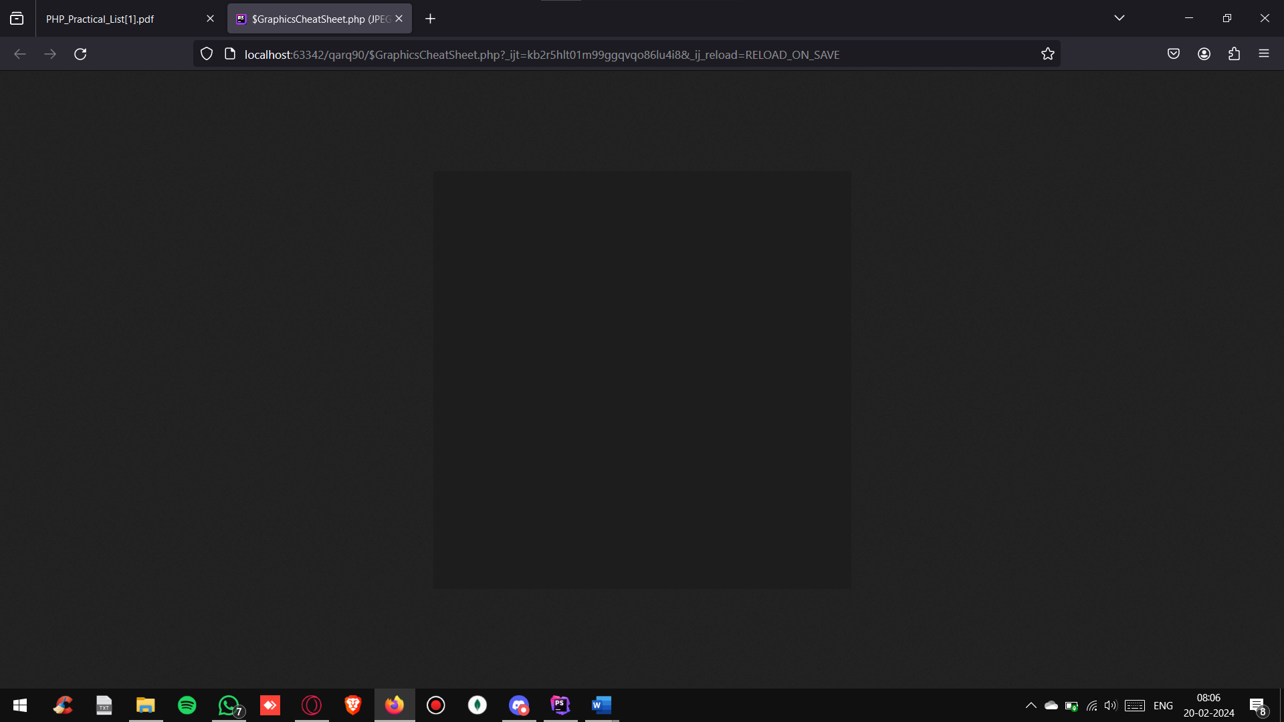

**2) Write a Program to create an image with text**

**CODE:**

<?php  
$width = 500;  
$height = 500;  
$img = imagecreate($width, $height);  
header('Content-Type: image/jpeg');  
$bg_color = imagecolorallocate($img, 29, 29, 29);  
$txt_color = imagecolorallocate($img, 255, 255, 255);  
imagestring($img, 10, 50, 50, "qarq90", $txt_color);  
imagejpeg($img);  
?>

**OUTPUT:**

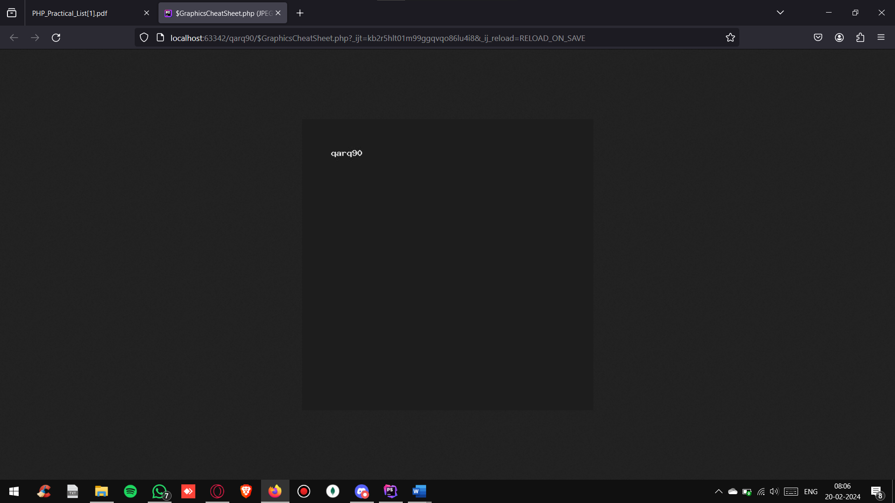

**3) Write a Program to create an image and display it in an html page**

**HTML CODE:**

<!DOCTYPE html>  
<html lang="en">  
<head>  
 <meta charset="UTF-8">  
 <title>Title</title>  
</head>  
<body>  
<img alt="" src="image.php">  
</body>  
</html>

**PHP CODE:**

<?php  
 $src=imagecreatefromjpeg('image.jpg');  
 $dst=ImageCreateTrueColor(900,900);  
 imagecopyresampled($dst,$src,10,10,20,20,500,500,600,600);  
 header('Content-Type: image/jpg');  
 imagejpeg($dst);  
?>

**OUTPUT:**

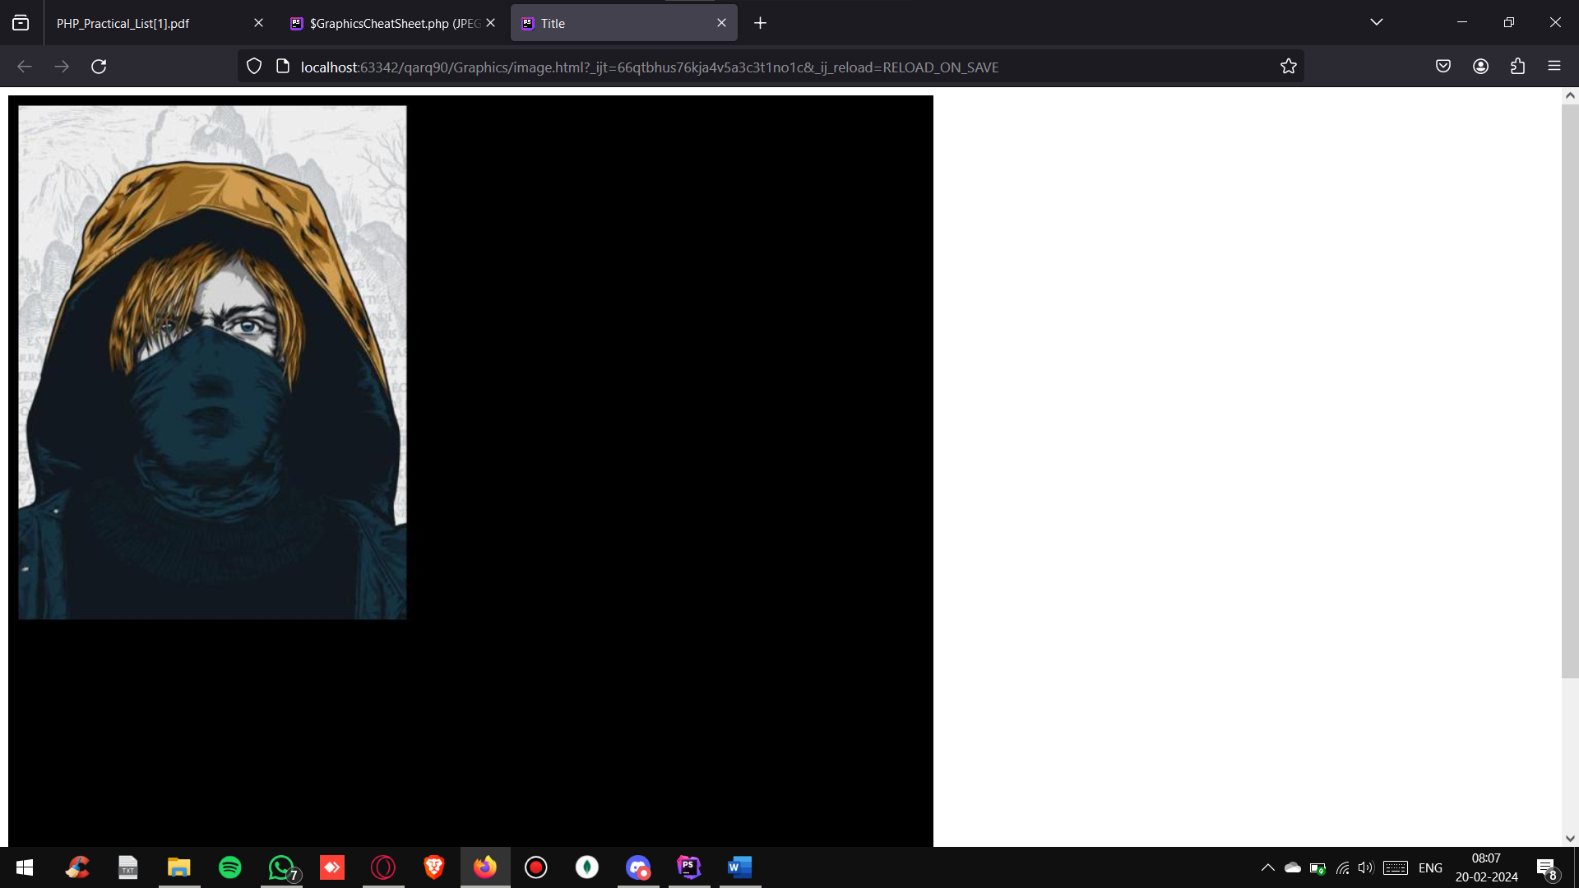

**4) Write a Program to demonstrate imagecopyresampled and imagecopyresized**

**HTML CODE:**

<!DOCTYPE html>  
<html lang="en">  
<head>  
 <meta charset="UTF-8">  
 <title>Title</title>  
</head>  
<body>  
<img alt="" src="image.php">  
</body>  
</html>

**PHP CODE:**

<?php  
 $src=imagecreatefromjpeg('image.jpg');  
 $dst=ImageCreateTrueColor(900,900);  
 imagecopyresampled($dst,$src,10,10,20,20,500,500,600,600);  
 imagecopyresized($dst,$src,100,100,200,200,800,800,900,900);  
 header('Content-Type: image/jpg');  
 imagejpeg($dst);  
?>

**OUTPUT:**

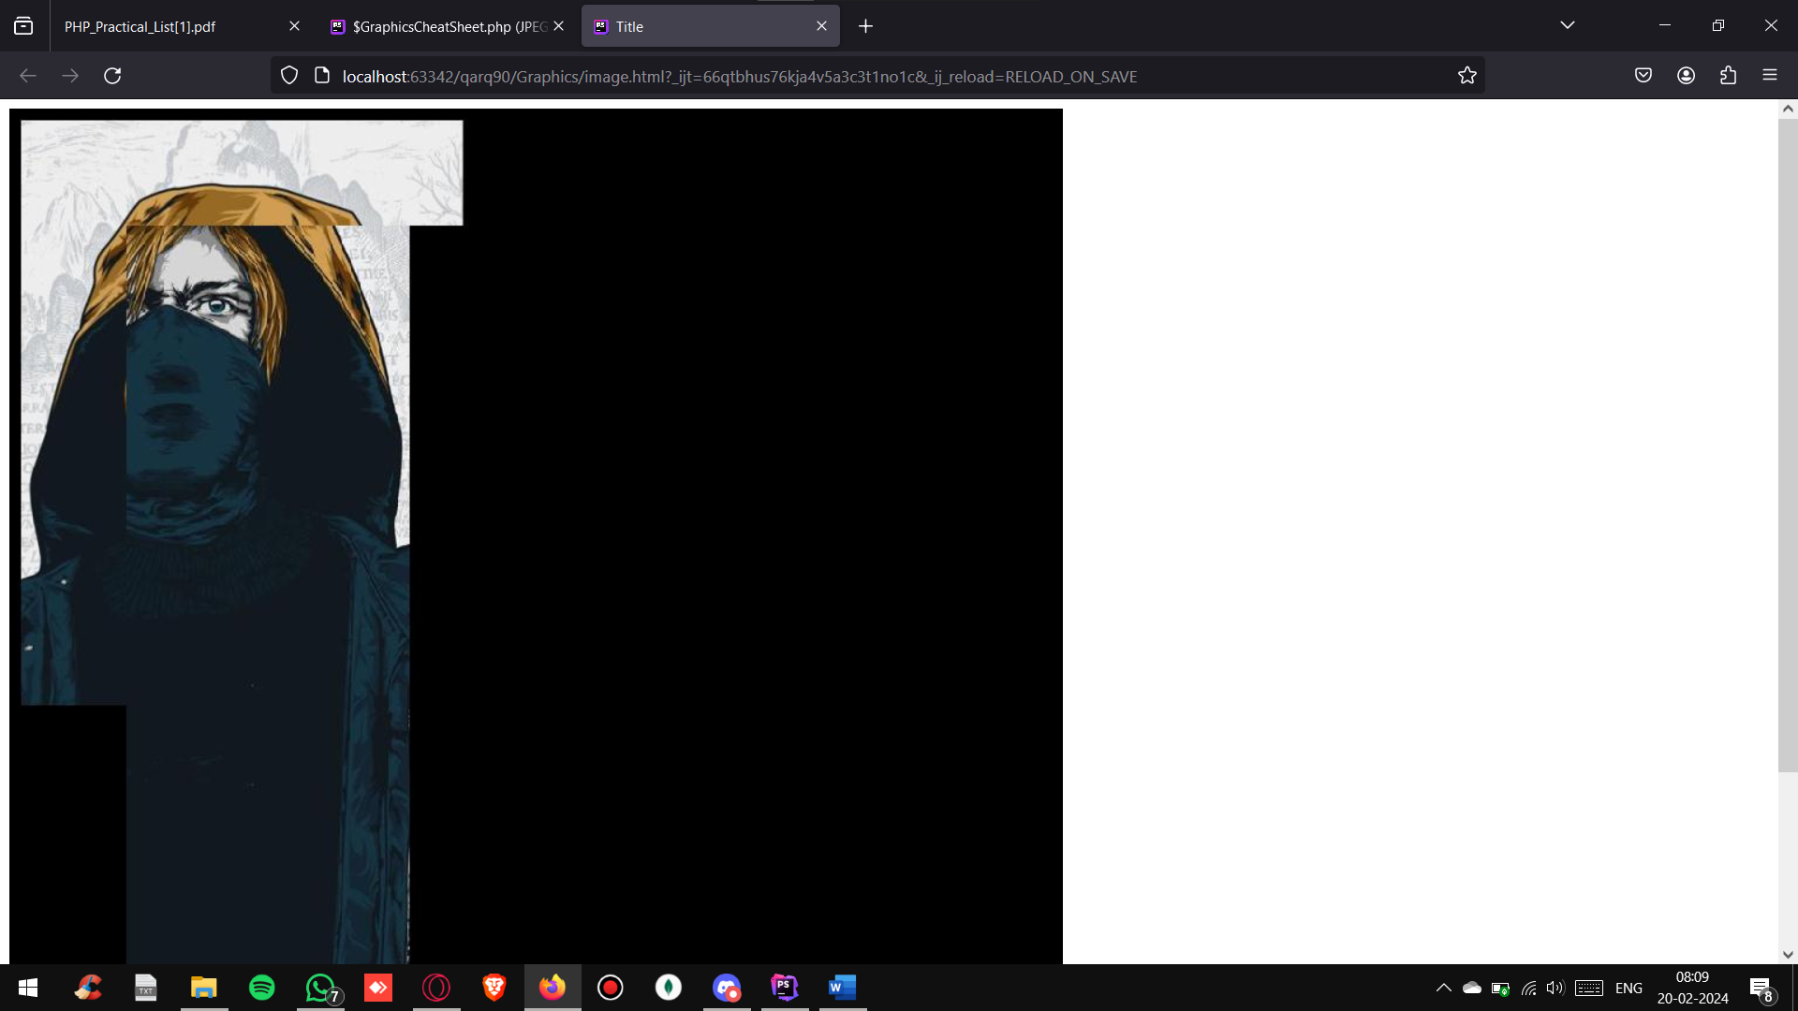

**5) Write a Program to create a PDF via FDPF library**

**CODE:**

<?php  
  
require("../fpdf/fpdf.php");  
  
$myPDF = new FPDF();  
  
$myPDF->AddPage();  
  
$row = file("./fpdf.txt");  
  
$myPDF->SetFont('Arial', 'B', 12);  
  
foreach ($row as $rowValue) {  
 $data = explode(';', $rowValue);  
 foreach ($data as $columnValue)  
 $myPDF->Cell(90, 12, $columnValue, 1);  
 $myPDF->SetFont('Arial', '', 12);  
 $myPDF->Ln();  
}  
$myPDF->Output();

**OUTPUT:**

